The Bubble Field
A Rigorous Scalar-Sector Formulation of the Universal Field of Least Action
Joseph Shields
29 July 2026

Executive statement
This document replaces the strongest unsupported claims in the first Bubble Field draft with a minimum consistent field model. It preserves the central physical picture:
Space is represented by least-action cells. Their local size and number density are the two scalar handles of the field. The metric, its stress-energy, and its observable gradients are to be reconstructed from those handles.
The first numerical program correctly reproduced the Schwarzschild values for solar light bending and Mercury’s anomalous precession. The exact interpretation is narrower than the first manuscript stated: those integrations reproduced the observables because the Schwarzschild radial metric profile was supplied to the integrator. They therefore establish that the proposed packing variables can represent the Schwarzschild geometry and that the spatial packing term is load-bearing inside that representation. They do not yet independently derive the Schwarzschild profile from microscopic bubble dynamics.
This correction does not remove the programme. It identifies its precise missing step: derive the dynamics of the two bubble handles and their coupling to matter, rather than inserting the gravitational profile in advance.
The completed minimum architecture is:
$$\left(α,ν,θ\right)→\left(T,P,u_{μ}\right)→g_{μν}→T_{μν}^{bubble}→\text{trajectories, lensing and clocks}.$$
Here
$$α=ln\left(a/a_{0}\right), ν=ln\left(n/n_{0}\right)$$
are the size and density modes, while the cyclic phase $θ$ fixes the future-directed time orientation.
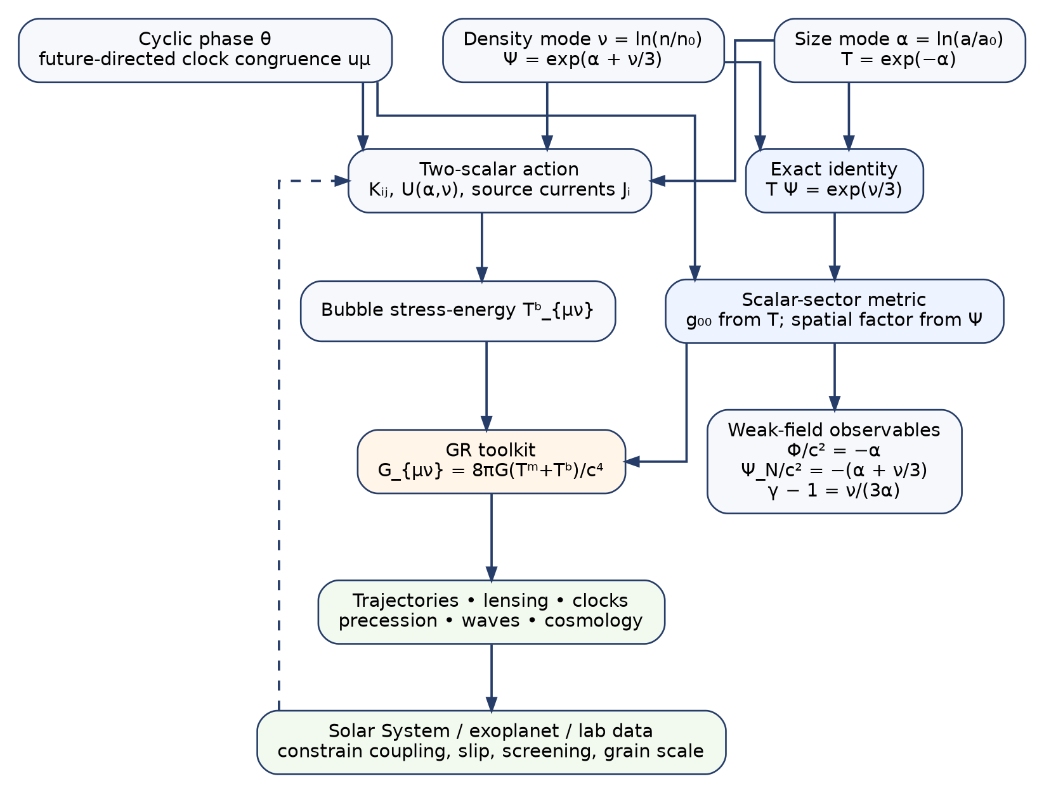
The rigorous architecture of the Bubble Field. The two scalar handles and the cyclic phase feed both a metric reconstruction and a field action; the resulting stress-energy is passed through general relativity as a geometric toolkit and confronted with Solar System, exoplanet and laboratory data.

1. Status ledger
The framework is now divided into five logically separate grades.
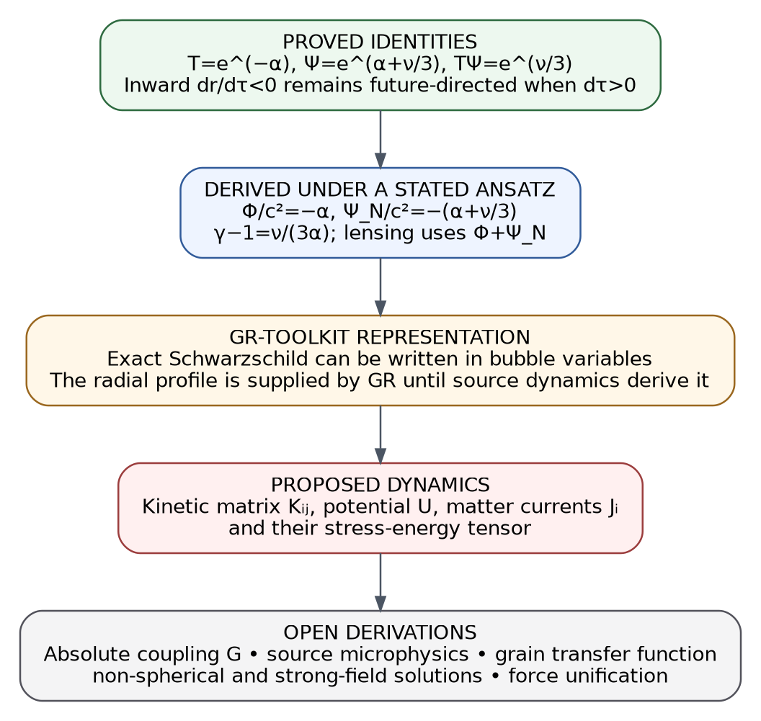
Status hierarchy of the rigorous formulation.
Grade | Statement
Proved identity | The definitions of bubble size, density, cycle rate and packing imply $TP=e^{ν/3}$.
Derived under a stated metric ansatz | The two bubble modes map to the two weak-field scalar gravitational potentials, and the density mode becomes gravitational slip.
Exact GR-toolkit representation | Schwarzschild geometry can be represented exactly by suitable bubble profiles in either areal or isotropic coordinates.
Proposed dynamics | A two-scalar action supplies equations of motion and a stress-energy tensor for the bubble modes.
Open derivation | The kinetic matrix, potential, source currents, absolute gravitational coupling, short-distance transfer function and force-unification claims must be derived from the least-action microphysics.
This grading prevents a benchmark reproduction from being called an independent derivation while retaining every result that genuinely follows.

2. Primitive objects

2.1 A bubble
A bubble is defined as a causal cell carrying one quantum of action:
$$ϵτ=ℏ, a=cτ.$$
The definition supplies a temporal extent $τ$, a causal size $a$, and an energy $ϵ$. The words least-action cell do not by themselves fix how cells interact, how they are created, or how matter changes their density. Those are dynamical questions and are kept separate.

2.2 The two scalar handles
Let the undisturbed state have cell size $a_{0}$ and proper number density $n_{0}$. Define dimensionless logarithmic fields
$$\boxed{α\left(x\right)=ln\frac{a\left(x\right)}{a_{0}}, ν\left(x\right)=ln\frac{n\left(x\right)}{n_{0}}.}$$
These variables are preferable to $a$ and $n$ directly because positivity is automatic:
$$a=a_{0}e^{α}, n=n_{0}e^{ν}.$$
They also linearise the weak-field relations.
- $α$ is the size or clock mode.
- $ν$ is the number-density mode.
They are independent handles. Locking $na^{3}$ to a constant would eliminate the packing degree of freedom by construction.

2.3 The cyclic phase and the arrow of evolution
The existing least-cost holonomy framework already contains a complex cyclic field
$$ψ=Re^{iθ}.$$
Where the phase gradient is timelike, define a future-directed unit congruence
$$\boxed{u_{μ}=−\frac{∇_{μ}θ}{\sqrt{−∇_{ρ}θ∇^{ρ}θ}}.}$$
The sign is chosen so that $u^{0}>0$. The phase is not a third force handle; it supplies the time orientation and local rest frame in which cell duration, size and density are measured.

3. The exact kinematic identity
A local clock counts cell cycles. Since $a=cτ$, the relative clock-rate factor is
$$T:=\frac{τ_{0}}{τ}=\frac{a_{0}}{a}=e^{−α}.$$
The packing length factor is obtained by counting cells per coordinate length and multiplying by their physical size:
$$P:={\left(\frac{n}{n_{0}}\right)}^{1/3}\frac{a}{a_{0}}=e^{α+ν/3}.$$
Therefore
$$\boxed{TP=e^{ν/3}.}$$
This equation is an identity. It replaces the earlier unconditional assertion $TP=1$.
The reciprocal lock follows only in a sector satisfying
$$ν=0.$$
Thus the previous relation becomes the constant proper-number-density branch:
$$\boxed{ν=0 ⇒ TP=1.}$$
This clarification is useful rather than destructive. It identifies $ν$ as an independently observable departure from the reciprocal time-space branch.

4. Negative inward motion is forward evolution
A negative spatial increment is not negative time evolution. Let $r$ increase outward and introduce inward depth
$$s:=r_{ref}−r.$$
For an inward-moving trajectory,
$$\frac{dr}{dτ}<0, \frac{ds}{dτ}=−\frac{dr}{dτ}>0.$$
At the same time, future-directed evolution requires
$$\frac{dτ}{dt}=T>0.$$
Hence
$$\boxed{\frac{dr}{dτ}<0\text{ and }\frac{dτ}{dt}>0}$$
means inward in space and forward in proper time. The negative sign labels orientation in the radial coordinate; it is not a reversal of the evolution parameter.
This is the rigorous version of the statement that the inward, negative-going branch remains positive evolution because the time orientation remains future-directed. In a phase formulation the same fact is carried by $u^{0}>0$, irrespective of the sign of a spatial component $u^{r}$.

5. Metric reconstruction

5.1 Scalar-sector reconstruction
Let $u_{μ}$ define the local time direction and let
$$h_{μν}={\overset{‾}{g}}_{μν}+u_{μ}u_{ν}$$
be the spatial projector relative to an auxiliary or reference geometry ${\overset{‾}{g}}_{μν}$. A minimum scalar-sector reconstruction is
$$\boxed{g_{μν}^{B}=−T^{2}u_{μ}u_{ν}+P^{2}h_{μν}.}$$
This is a conformal-disformal map: the phase defines the time direction, $α$ scales clocks, and $α+ν/3$ scales the orthogonal spatial sector.
This ansatz does not represent every possible spacetime metric. Two scalars describe the scalar gravitational sector; vector and tensor gravitational modes require the phase congruence, additional geometry, or a more general tetrad construction. That limitation is explicit.

5.2 Weak-field map
Write the weak-field metric in Newtonian gauge as
$$ds^{2}=−\left(1+\frac{2Φ}{c^{2}}\right)c^{2}dt^{2}+\left(1−\frac{2Ψ_{g}}{c^{2}}\right)dx^{2}.$$
Expanding the bubble factors,
$$T^{2}=e^{−2α}≃1−2α,$$
$$P^{2}=e^{2α+2ν/3}≃1+2α+\frac{2ν}{3}.$$
Comparison gives
$$\boxed{\frac{Φ}{c^{2}}=−α, \frac{Ψ_{g}}{c^{2}}=−\left(α+\frac{ν}{3}\right).}$$
The gravitational slip parameter is therefore
$$\boxed{γ:=\frac{Ψ_{g}}{Φ}=1+\frac{ν}{3α}.}$$
The density mode is no longer merely a visual overcrowding variable. It is an observable difference between the time potential and spatial-curvature potential.

5.3 The factor of two, stated correctly
Slow nonrelativistic matter responds primarily to
$$a_{slow}=−∇Φ.$$
Light deflection and Shapiro delay depend on the lensing potential
$$Φ+Ψ_{g}.$$
A time-only model has $Ψ_{g}=0$, equivalent to $γ=0$. The reciprocal vacuum branch $ν=0$ gives
$$Ψ_{g}=Φ, γ=1,$$
so
$$Φ+Ψ_{g}=2Φ.$$
Thus the spatial packing mode supplies the second half of the weak-field light-bending effect. This is a rigorous scalar-perturbation statement. It does not require claiming that the Schwarzschild profile has already been microscopically derived.
The Cassini radio experiment found
$$γ=1+\left(2.1±2.3\right)×{10}^{−5}.$$
In the present variables, a long-range unscreened density mode in the Solar System must therefore satisfy approximately
$$\left|\frac{ν}{α}\right|≲2×{10}^{−4}$$
at conservative two-standard-deviation order. A larger density mode would require screening, short range, environmental dependence, or a revised metric map.

6. Exact Schwarzschild representation

6.1 Areal-radius representation
Let
$$m=\frac{GM}{c^{2}}, f\left(r\right)=1−\frac{2m}{r}.$$
The Schwarzschild line element is
$$ds^{2}=−f\left(r\right)c^{2}dt^{2}+\frac{dr^{2}}{f\left(r\right)}+r^{2}dΩ^{2}.$$
It is represented by
$$T\left(r\right)=\sqrt{f\left(r\right)}, P_{r}\left(r\right)=\frac{1}{\sqrt{f\left(r\right)}}.$$
Hence
$$α\left(r\right)=−\frac{1}{2}lnf\left(r\right), TP_{r}=1.$$
The exact size mode is therefore
$$\boxed{α_{Schw}\left(r\right)=−\frac{1}{2}ln\left(1−\frac{2GM}{rc^{2}}\right).}$$
Its Newtonian limit is
$$α_{Schw}\left(r\right)=\frac{GM}{rc^{2}}+O​\left(\frac{G^{2}M^{2}}{r^{2}c^{4}}\right).$$
This corrects the earlier use of $T=1+Φ/c^{2}$ as an exact equation. That relation is the first-order limit; the exact Schwarzschild clock factor is $T=\sqrt{1+2Φ_{N}/c^{2}}$ when $Φ_{N}=−GM/r$.

6.2 What the representation establishes
Once the profile $f\left(r\right)$ is supplied, the bubble variables reproduce the exact metric and therefore its light bending, precession, redshift and geodesics. The original numerical integrations are valid benchmark checks of this representation.
They establish:
- the packing contribution is necessary for the full GR light response;
- the two-handle language can encode exact Schwarzschild geometry;
- the numerical implementation is consistent with the metric it was given.
They do not yet establish:
- that $f\left(r\right)$ follows uniquely from the least-action cell definition;
- that arbitrary matter distributions source $α$ and $ν$ correctly;
- that $G$ is derived rather than calibrated.

6.3 Coordinate discipline
In isotropic radius $ρ$, Schwarzschild is
$$ds^{2}=−{\left(\frac{1−m/\left(2ρ\right)}{1+m/\left(2ρ\right)}\right)}^{2}c^{2}dt^{2}+{\left(1+\frac{m}{2ρ}\right)}^{4}dx^{2}.$$
The same geometry is represented by
$$T=\frac{1−m/\left(2ρ\right)}{1+m/\left(2ρ\right)}, P={\left(1+\frac{m}{2ρ}\right)}^{2},$$
which gives
$$α=−lnT, ν=3\left(lnP−α\right).$$
Consequently, the statement $ν=0$ is gauge-specific unless $n$ is defined covariantly as a proper number density relative to the phase congruence and a specified physical volume form. A rigorous source theory must make that definition explicit.

7. The baseline cell scale
Take the vacuum energy density $ρ_{Λ}$ directly as the measured input. Do not reconstruct it from $H_{0}$, $Ω_{Λ}$ and $G$ if the purpose is to test whether $G$ can later be derived independently.
If the baseline cells fill the undisturbed state,
$$n_{0}=a_{0}^{−3}, ρ_{Λ}=ϵ_{0}n_{0}.$$
Using
$$ϵ_{0}τ_{0}=ℏ, a_{0}=cτ_{0},$$
one obtains
$$\boxed{τ_{0}={\left(\frac{ℏ}{ρ_{Λ}c^{3}}\right)}^{1/4}, a_{0}={\left(\frac{ℏc}{ρ_{Λ}}\right)}^{1/4}.}$$
For
$$ρ_{Λ}=5.32398×{10}^{−10} J m^{−3},$$
this gives
Quantity | Value
duration $τ_{0}$ | $2.92816×{10}^{−13} s$
size $a_{0}$ | $8.77840×{10}^{−5} m=87.784 μm$
energy $ϵ_{0}$ | $3.60149×{10}^{−22} J=2.24787 meV$
number density $n_{0}$ | $1.47827×{10}^{12} m^{−3}$
This scale is a conditional prediction of the causal-cell interpretation. The dimensional combination itself is known; the new physical claim is that it is the size of an actual least-action cell and should produce a specified observable transfer function.

8. Vacuum pressure and the creation issue
A constant vacuum term in a covariant action has stress-energy
$$T_{μν}^{\left(Λ\right)}=−ρ_{Λ}g_{μν},$$
so
$$p=−ρ_{Λ}, w=−1.$$
That result is rigorous once $U\left(0,0\right)=ρ_{Λ}$ is included in the field potential.
The microscopic sentence “an expanding region simply contains more fixed cells” additionally assumes a cell-creation law. Let
$$N^{μ}=nu^{μ}$$
be the cell-number current. Constant proper density in an expanding congruence requires
$$∇_{μ}N^{μ}=nΘ, Θ:=∇_{μ}u^{μ},$$
rather than ordinary number conservation $∇_{μ}N^{μ}=0$. This creation rule may eventually follow from the phase/action dynamics, but it is not a consequence of $ϵτ=ℏ$ alone.

9. A covariant two-scalar action
Let
$$q^{I}=\left(α,ν\right), I=1,2.$$
A minimum healthy scalar action is
$$\boxed{S_{B}=∫d^{4}x\sqrt{−g}\left[−\frac{1}{2}K_{IJ}\left(q\right)∇_{μ}q^{I}∇^{μ}q^{J}−U\left(q\right)+L_{int}\left(q,θ,χ\right)\right].}$$
Here $χ$ denotes ordinary matter fields. The kinetic matrix must be positive definite in the physical regime:
$$K_{αα}>0, K_{νν}>0, detK>0.$$
These are the minimum no-ghost conditions.
The Euler-Lagrange equations are
$$\boxed{∇_{μ}\left(K_{IJ}∇^{μ}q^{J}\right)−\frac{1}{2}∂_{I}K_{JK}∇_{μ}q^{J}∇^{μ}q^{K}−∂_{I}U=J_{I},}$$
where
$$J_{I}:=−\frac{∂L_{int}}{∂q^{I}}$$
are matter and phase source currents.

9.1 Stress-energy from the field
The bubble field does not need a stress tensor bolted onto it. Once the action is supplied, its stress-energy is the metric variation
$$T_{μν}^{B}=−\frac{2}{\sqrt{−g}}\frac{δS_{B}}{δg^{μν}}.$$
For the two-derivative scalar action,
$$\boxed{T_{μν}^{B}=K_{IJ}∇_{μ}q^{I}∇_{ν}q^{J}−g_{μν}\left[\frac{1}{2}K_{IJ}∇_{ρ}q^{I}∇^{ρ}q^{J}+U\left(q\right)\right]+T_{μν}^{int}.}$$
This tensor contains energy density, momentum flux, isotropic pressure and anisotropic stress produced by spatial gradients. It is exactly the object required to connect the bubble field to general relativity.

10. General relativity as the toolkit
The conservative completion treats general relativity as the geometric conversion rule:
$$\boxed{G_{μν}+Λg_{μν}=\frac{8πG}{c^{4}}\left(T_{μν}^{matter}+T_{μν}^{B}\right).}$$
The bubble theory must then specify $K_{IJ}$, $U$, $J_{I}$, and the relation between $\left(α,ν,θ\right)$ and the metric sector. GR determines how the resulting stress-energy curves spacetime and how matter and radiation propagate.
There are two possible levels of commitment:

GR-coupled field completion
The metric is an independent variable. The bubble fields are covariant matter fields with stress-energy. Their weak-field values are interpreted through the potential map of Section 5.

Emergent-metric completion
The physical metric is reconstructed algebraically from $\left(α,ν,θ\right)$, and the Einstein-Hilbert action is reduced to those variables:
$$S_{red}\left[q,θ\right]=\frac{c^{4}}{16πG}∫\sqrt{−g_{B}\left(q,θ\right)}R\left[g_{B}\left(q,θ\right)\right] d^{4}x+S_{B}+S_{m}.$$
Variation gives projected Einstein equations
$$\frac{δg_{μν}^{B}}{δq^{I}}\left(G^{μν}−\frac{8πG}{c^{4}}T^{μν}\right)=0.$$
This is closer to the intended claim that the metric is bubble packing, but it is also more restrictive and requires a complete covariant reconstruction map. It remains the stronger open programme.

11. Minimum source equations
Linearising around the baseline state gives a general two-field system
$$\boxed{K∇^{2}q−M^{2}q=−Cρ, q=\left(\begin{matrix}α \\ ν\end{matrix}\right).}$$
The matrices have distinct roles:
- $K$: field stiffness and kinetic mixing;
- $M^{2}$: ranges and screening scales;
- $C$: coupling of matter to size and density modes.
The Newtonian limit fixes one observed combination. Since
$$Φ=−c^{2}α,$$
recovering
$$∇^{2}Φ=4πGρ$$
requires
$$∇^{2}α=−\frac{4πG}{c^{2}}ρ$$
for the long-range eigenmode.
This equation can be used in two ways:
- Calibration: insert measured $G$ and test the rest of the bubble theory.
- Derivation target: derive the coefficient $4πG/c^{2}$ from $K$, $C$, $ℏ$, $c$, and the vacuum cell structure.
The second is required before claiming a derivation of $G$.
A screened density mode may obey
$$\left(∇^{2}−λ_{ν}^{−2}\right)ν=−β_{ν}\frac{4πG}{c^{2}}ρ.$$
The parameters $β_{ν}$ and $λ_{ν}$ are not free decorations: Solar System slip, lensing, binary pulsars and cosmological structure constrain them.

12. Computed source example
The accompanying program solves a smooth spherical toy source with total solar mass. It uses
$$∇^{2}α=−\frac{4πG}{c^{2}}ρ$$
and a screened illustrative equation for $ν$. The purpose is not to declare the source sector solved. It verifies that the proposed equations are numerically well posed, reconstruct the metric factors, and expose the density mode directly as gravitational slip.
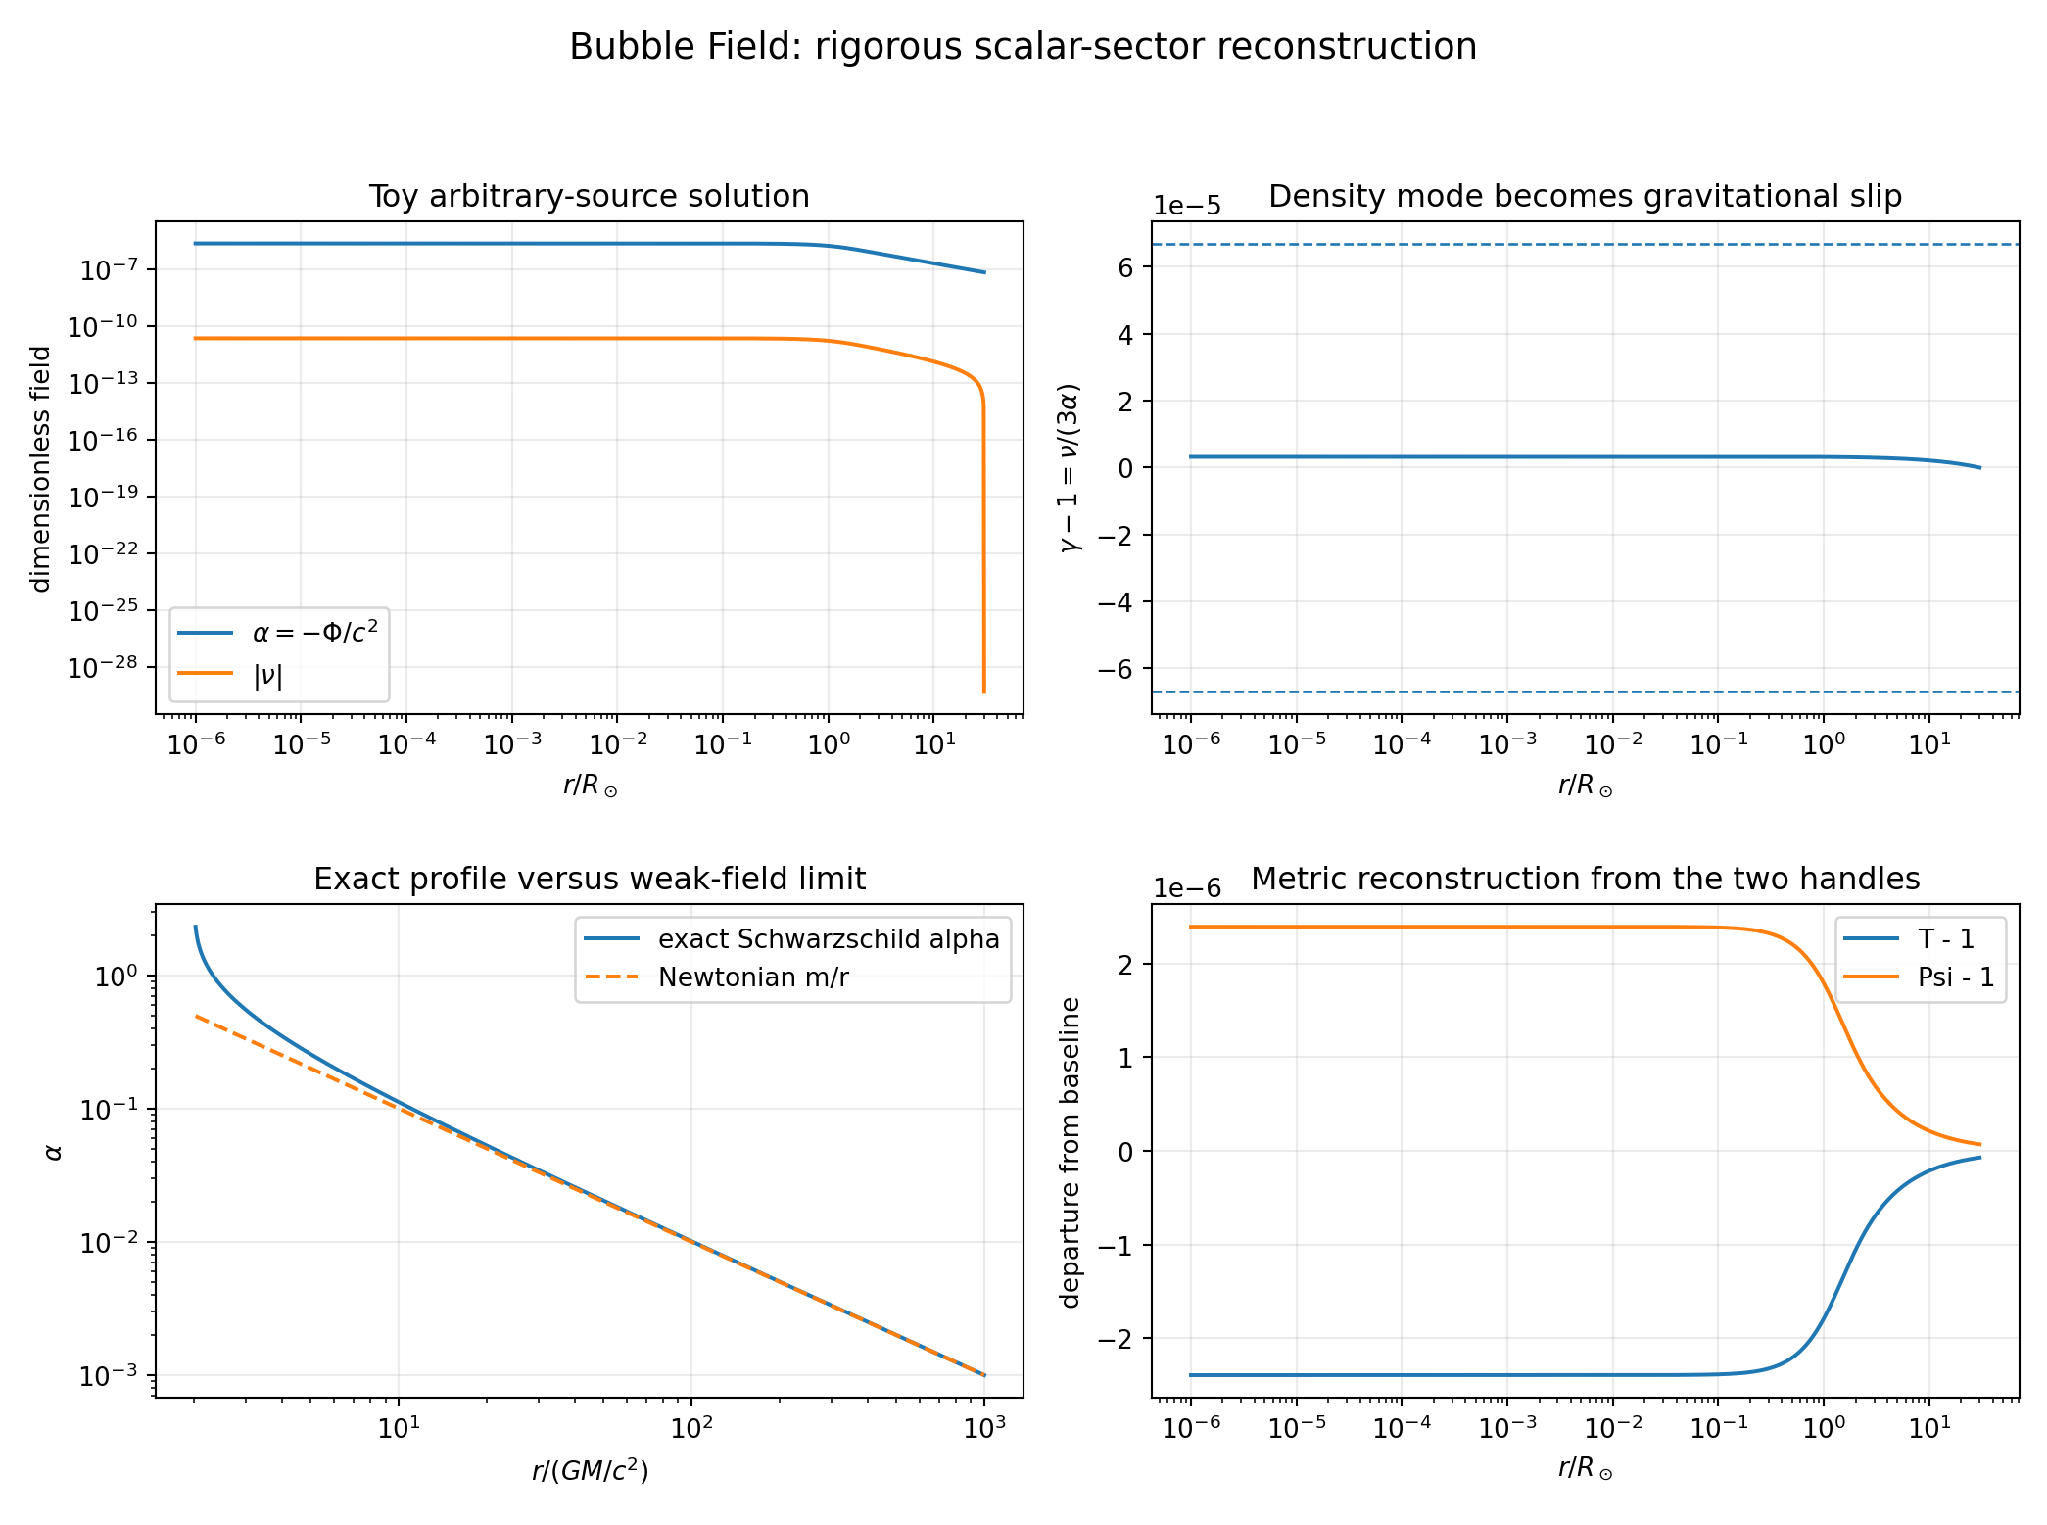
Computed profiles from the rigorous script. Top left: the long-range size mode and a screened density mode. Top right: the density mode expressed as gravitational slip and compared with an indicative Cassini band. Bottom left: the exact Schwarzschild size profile and its Newtonian limit. Bottom right: departures of the reconstructed clock and packing factors from the baseline.
The numerical certificate reports:
Check | Result
exact identity maximum error | $2.22×{10}^{−16}$
exact areal Schwarzschild mapping error | $1.11×{10}^{−16}$
exact isotropic mapping error | $2.22×{10}^{−15}$
toy Poisson relative $L^{2}$ residual | $1.25×{10}^{−5}$
toy maximum $\left|γ−1\right|$ | $3.22×{10}^{−6}$
inward-forward sign check | passed
The toy density coupling and screening length are illustrative. They demonstrate the workflow that future data fitting must use; they are not derived constants.

13. Reinterpreting the original numerical tests

13.1 Light bending
The original program compared:
- time dilation with no spatial packing;
- time dilation plus the Schwarzschild reciprocal radial factor.
The first returns approximately half the relativistic solar deflection, while the second returns the full value. That is consistent with the weak-field relation
$$δθ∝\left(1+γ\right)\frac{GM}{bc^{2}}.$$
The computation therefore demonstrates that the spatial potential is load-bearing. It does not by itself derive $γ=1$ from bubble microphysics. In the rigorous formulation that derivation target becomes
$$ν=0 \text{or, more generally,} \frac{ν}{α}→0$$
in the unscreened Solar System exterior.

13.2 Mercury precession
The full Schwarzschild mapping reproduces the relativistic precession because its geodesic equation is Schwarzschild’s. The bubble programme must now derive the required nonlinear radial profile or the equivalent post-Newtonian coefficients from its field action.

13.3 The two-body force
The earlier calculation began from the Newtonian potential
Φtotal=−i​GMix−xi
and then rewrote its gradient through the overcrowding variable. It is therefore a successful reparameterisation of Newtonian attraction, not an independent derivation of it.
The next valid calculation begins instead with $ρ\left(x\right)$, solves the coupled $\left(α,ν\right)$ equations, reconstructs $Φ$, and only then compares the predicted acceleration with Newtonian and relativistic observations.

14. Information recovered by the visual field systems
The Solar System and exoplanet sites remain valuable because they implement a common relational frame
$$\left(r,v,g\right).$$
From it one obtains:
$$v_{r}=v⋅\hat{r}, h=r×v, τ=r×g,$$
$$κ_{orbit}=\frac{\left|v×g\right|}{{\left|v\right|}^{3}}, \frac{dA}{dt}=\frac{1}{2}\left|h\right|.$$
The field map compresses position, retained momentum and selected acceleration into one local grammar. Across space it also provides divergence, curl, tidal eigenvectors, critical points, separatrices, shared boundaries and closure nesting.
The exoplanet ensemble recovers the source parameter
$$μ=GM$$
and tests the scaling
$$\left|g\right|∝M^{η}r^{p}.$$
It cannot separate $G$ from the absolute source mass without a non-gravitational mass calibration or a microphysical prediction of the coupling. The Bubble Field’s task is therefore not to relabel $GM$, but to derive the source current and stiffness that fix the coefficient in the $α$ equation.

15. Experimental programme

15.1 Short-distance structure
The baseline cell construction gives
$$a_{0}≃87.8 μm.$$
A real discrete cell scale must not merely be announced. It must generate a transfer function or correlation signature, for example
$$Φ\left(k\right)=−\frac{4πG}{k^{2}} F\left(ka_{0}\right)ρ\left(k\right), F\left(0\right)=1.$$
Different microstructures produce different $F$: suppression, oscillation, anisotropic noise, stochastic granularity, or a modified dispersion relation. The model must derive one.
Torsion-balance experiments have tested the inverse-square law down to separations of approximately $52 μm$ without reporting a standard Yukawa deviation. That does not automatically exclude every possible granularity signal at $87.8 μm$, but it makes the scale immediately exposed and forces a quantitative comparison with the published apparatus response.

15.2 Gravitational slip
The direct scalar diagnostic is
$$γ−1=\frac{ν}{3α}.$$
This should be confronted with:
- Cassini time delay;
- solar light deflection;
- galaxy dynamics versus lensing;
- cosmological weak lensing and redshift-space distortions;
- gravitational-wave propagation if the covariant completion alters tensor modes.

15.3 Equivalence principle
Matter may couple differently to $α$ and $ν$. Universal free fall requires the effective matter metric or source currents to be composition-independent to experimental accuracy. This is a direct constraint on $L_{int}$.

15.4 Strong-field systems
Neutron stars and black-hole perturbations test whether the bubble scalar sector introduces extra radiation, scalarisation, altered ringdown, or a breakdown of the two-handle description. The exact Schwarzschild representation is not enough; its stability and sourced formation must be derived.

16. What is now locked in
The following statements can be used as the formal core.

Definition: Bubble Field
The Bubble Field is a phase-oriented, two-scalar field system whose local size mode $α=ln\left(a/a_{0}\right)$ and number-density mode $ν=ln\left(n/n_{0}\right)$ reconstruct clock rate and spatial packing through $T=e^{−α}$ and $P=e^{α+ν/3}$. The cyclic phase defines the future-directed congruence. A covariant action for these variables produces their stress-energy, and general relativity supplies the geometric toolkit relating that stress-energy to observable motion and radiation.

First theorem: Packing identity
$$TP=e^{ν/3}.$$
The reciprocal time-space relation is the $ν=0$ branch.

Second theorem: Weak-field potential map
Under the scalar metric reconstruction,
$$Φ=−c^{2}α, Ψ_{g}=−c^{2}\left(α+\frac{ν}{3}\right).$$
Therefore
$$γ−1=\frac{ν}{3α}.$$

Orientation principle
$$\frac{dr}{dτ}<0, \frac{dτ}{dt}>0$$
is inward spatial evolution under positive proper-time evolution. The minus sign is directional, not temporal reversal.

GR-toolkit principle
The bubble action supplies $T_{μν}^{B}$; general relativity converts total stress-energy into geometry. Exact known metrics may be represented in bubble variables, but independent derivation requires the bubble source equations to produce their profiles from matter and boundary data.

17. Open equations, stated exactly
The theory is not complete until the following are fixed:
- Kinetic matrix $K_{IJ}\left(α,ν\right)$.
- Potential $U\left(α,ν\right)$, including the vacuum minimum and any size floor.
- Matter currents $J_{α}$ and $J_{ν}$.
- Phase dynamics determining $u_{μ}$ and cell creation or annihilation.
- Absolute coupling that becomes $G$ in the long-range limit.
- Covariant density definition and its relation to coordinate volume.
- Short-distance transfer function near $a_{0}$.
- Non-spherical and time-dependent solutions.
- Strong-density limit before any confinement claim can be made.
These are not vague future tasks. They are the exact mathematical unknowns left by the rigorous reduction.

18. Immediate computational sequence
The next calculations should be performed in this order.

Calculation 1: Derive the linear mode spectrum
Expand
$$U=ρ_{Λ}+\frac{1}{2}q^{I}{\left(M^{2}\right)}_{IJ}q^{J}+O\left(q^{3}\right)$$
and diagonalise $K^{−1}M^{2}$. This determines the propagating combinations, their ranges, and whether either mode is unstable or ghostlike.

Calculation 2: Solve a finite source without importing $Φ$
Choose a smooth density $ρ\left(r\right)$, solve the coupled radial equations, and derive $Φ$, $Ψ_{g}$, acceleration and lensing from the solution. The supplied rigorous script performs the first calibrated toy version of this workflow.

Calculation 3: Fit the density mode
Use Cassini and the Solar System map to constrain $ν/α$, then extend the same parameters to binary and galactic systems. One coupling and one screening law must survive all scales.

Calculation 4: Derive the grain signature
Compute $F\left(ka_{0}\right)$ from an explicit cell lattice, random packing, foam, or continuum limit. Confront the resulting force or noise spectrum with short-range gravity data.

Calculation 5: Derive, do not assume, the source coupling
Relate $J_{I}$ to the energy, phase and boundary invariants of a matter closure. This is the step that can convert the exoplanet result $GM$ into a derivation of $G$ or show that $G$ remains an empirical coupling.

19. Reproducibility package
The package accompanying this paper contains:
- bubble_field_rigorous.py — definitions, exact identities, Schwarzschild representation checks, a covariant action certificate, a toy arbitrary-source solver, gravitational-slip output and future-time orientation check;
- bubble_field_rigorous_results.json — machine-readable numerical certificate;
- bubble_field_rigorous_profiles.png — generated profiles;
- the original Bubble Field script and manuscript, retained as historical inputs rather than silently overwritten.

20. Closing
The bubble picture becomes a field theory only when its variables, metric map, action, source equations and status boundaries are all explicit. That has now been done at the minimum consistent level.
The result is stronger than the original claim in one respect and narrower in another.
It is narrower because Schwarzschild observables are not counted as independently derived while the Schwarzschild profile is an input.
It is stronger because the framework now exposes a new, direct observable:
$$\boxed{γ−1=\frac{ν}{3α}.}$$
The density handle is precisely the gravitational-slip degree of freedom, the size handle is the clock potential, and the phase fixes forward evolution. Their action generates a stress tensor. General relativity can then be used as the toolkit without being mistaken for the microscopic origin of the fields.
The decisive question is no longer whether bubbles can be drawn around gravity. It is whether one action, one potential and one matter coupling can produce the measured long-range mode, suppress or screen the density mode where required, and predict a unique short-distance signature near the claimed cell scale.
That is a closed research programme with equations, observables and failure conditions.

References
- Shields, J. (2026). Least-Cost Holonomy and Co-Distinction Fields: The Shields Field of Distinct Actions. Working paper.
- Shields, J., with computation by Claude (2026). The Bubble Field: Gravity as Overcrowding in a Sea of Least-Action Cells. Working manuscript and code certificate.
- Bertotti, B., Iess, L. & Tortora, P. (2003). “A test of general relativity using radio links with the Cassini spacecraft.” Nature 425, 374–376. doi:10.1038/nature01997.
- Lee, J. G., Adelberger, E. G., Cook, T. S., Fleischer, S. M. & Heckel, B. R. (2020). “New Test of the Gravitational 1/r² Law at Separations down to 52 μm.” Physical Review Letters 124, 101101. doi:10.1103/PhysRevLett.124.101101.
- Carroll, S. M. (2004). Spacetime and Geometry. Addison-Wesley.
- Wald, R. M. (1984). General Relativity. University of Chicago Press.
- Will, C. M. (2014). “The Confrontation between General Relativity and Experiment.” Living Reviews in Relativity 17, 4.
- Ma, C.-P. & Bertschinger, E. (1995). “Cosmological Perturbation Theory in the Synchronous and Conformal Newtonian Gauges.” Astrophysical Journal 455, 7.

